COMP 116
Programming Assignment #1
Images as Matrices
Due Saturday, September 4 by 11:59pm

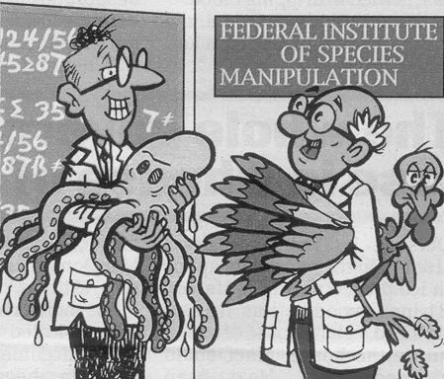
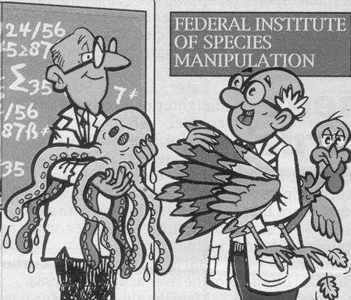
This assignment will give you experience with retrieving files from Sakai, loading them into MATLAB, using MATLAB script files, creating a report of your results, and submitting it via Dropbox. It also illustrates that MATLAB can be used to manipulate images (since an image can be represented as a matrix).

We show this in two ways. First we will use MATLAB to “find ten differences between these two images,” like the puzzles you might see in a magazine (this one is from Globe). Then we will use MATLAB to “morph” two faces together in a single image.

Downloading the images
The images that you will use in this assignment are posted on Sakai. To find them, click on the “Resources” link in the left column. You will then see a list of all the files that are available for download; the images needed for this assignment are in the folder named “Assignment1Resources”. There are 4 images: Left.png, Right.png, head01.png, & head02.png.

Changing your working directory
Start MATLAB, and change your working directory to the directory where you saved the images. In MATLAB, you can change directories by typing cd theDirectoryName in the MATLAB command window, or you can click on the … to right of the “Current Folder:” box in the toolbar. For example, if you saved the images in C:\comp116stuff, you could either type

cd C:\comp116stuff

in the MATLAB command window, or click the … and navigate to that directory.

Loading and displaying an image in MATLAB
Create a new script file in MATLAB (Go to the “File” menu, and choose New -> Script), and name it Assignment1.m. Type the following into the new script:

%% Displaying an image
% Show directory information. Then load and display the left image.
dir
leftImg = imread('Left.png');
imagesc(leftImg);
axis image;
colormap(gray(256));

The first two lines in green are comments. This means that they do not actually contribute anything to the behavior of the program; they are just there to explain how the program works. In MATLAB, a percent symbol (%) indicates that the rest of that line is a comment. Note that the first line starts with %% instead of %. This tells MATLAB to create a new cell, which we will revisit later

The first command (dir) lists the files in the current working directory.

The second command (leftImg = imread('Left.png');) reads in the image named Left.png as a matrix whose entries are integers between 0 and 255, and stores it in the variable named leftImg. Note that putting a semicolon (;) at the end of a line tells MATLAB not to display the results of that command. If you delete the semicolon, MATLAB will show the matrix.

The third command (imagesc(leftImg);) displays that image. Specifically, imagesc(...) is the MATLAB command to display an image, and we are telling it to display the image stored in
leftImg. This will display the image with default options, which are not appropriate for this image, so the next two commands modify how the image is displayed. The command axis image; sets the aspect ratio of the image, and the command colormap(gray(256)); sets the colormap of the image to be grayscale with 256 levels. (The colormap is how MATLAB associates the contents of the matrix--which are integers between 0 and 256--with the colors of each pixel.) Try commenting out each of those last two lines to see how they effect the appearance of the image.

Hit CTRL-Enter to execute the current cell, or press the play button on the editor tool bar to run the script, or enter “Assignment01” in the Command Window.

In the MATLAB Command Window, execute the following command:

>> publish Assignment1.m;

After some time, you will see an html folder appear in your current directory that contains some image files and an html file. Open this file in a browser to see the published version of your script.

Loading a second image and creating the difference image
Now, we can load the other image and see what happens when you subtract one drawing from the other. Before we do this, we convert both images to real (double precision) numbers, rather than integers. Do this in a new cell in your script. (That is, make sure that the first line starts with %%.)

%% Creating a difference image
% Load another image, convert both images to doubles, and display an
% difference image.
rightImg = imread('Right.png');
leftImg = double(leftImg);
rightImg = double(rightImg);
imagesc(leftImg-rightImg);
axis image;
colormap(gray(256));

In the difference image, parts of the image that are the same in both Left.png and Right.png show up as gray, and things that are different appear as black or white. It should be easy to identify the differences in this image.

Image morphing
In the example we just did, we subtracted the two input images to create a difference image, an image that highlights the differences between the two images. Now, we are going to blend two input images, so we can make them look more the same. Create a new cell in your script, and enter the following:

%% Loading the first picture
% Load and display the first picture.
img01 = imread('head01.png');
imagesc(img01);
axis image;

Now create another new cell in your script, and enter the following code. We do this in two steps, so you can see what both of the input images look like before you create the morphed image.

%% Loading the second picture
% Load and display the second picture.
img02 = imread('head02.png');
imagesc(img02);
axis image;

Now that both images are loaded, we can create a morphed image. Create a new cell and entter the following:

%% Compute and display the average image
% Compute and display the average image
img03 = 0.5*img01 + 0.5*img02;
imagesc(img03);
axis image;

EXTRA: Weighted sums (morphing the image)
The above code displays an image that is exactly the average of the two input images (0.5 of each). You can make it look more like one or the other by changing the weights on each image. For example, replacing img03 = 0.5*img01 + 0.5*img02; with

img03 = 0.33*img01 + 0.67*img02;

will produce a result image that has “twice as much” of the second image as of the first image. Different values of a and b (that is, different weights) will produce different images. (NOTE: If you choose a weight such that 0 <= a <= 1 and b = (1 – a)– like we did here – then this is called interpolating between the two images. )

Note that if these 3 commands are in their own cell (and they should be, right?), you can change the weights and re-execute just that cell by pressing CTRL-Enter.

Format of your report
Everything you write for the assignments in this class will be written right in the MATLAB script file; you won’t submit an additional text file, Word document, etc. So in addition to your code, the script file needs to contain your personal info as well as any discussion

At the top of your script file, you should create a cell (that is, type %% at the beginning of it) that contains your name, the names of anyone you collaborated with, your honor code pledge, etc. as comments (that is, lines that start with %).

Below that, you should create another cell where you will type a brief introduction to the assignment as comments.

At the end of your script, you should create another cell, where you will write briefly (again in comments) about what parts of the assignment you had trouble with, what parts you couldn’t get working right, what you learned in the course of the assignment, etc.

Turning in the assignment
Publish your completed script file (by typing publish Assignment1.m; in the MATLAB command window). Create a folder inside your shared Dropbox folder named Assignment1. Copy the published html and image files into that directory.

Required Components: [100 pts]
- Turn in your script as an HTML file using MATLAB’s publish function. [5 pts]
- List the contents of the current directory using dir.[5 pts]
- Display Left.png using imagesc.[10 pts]
- Display the difference image created from Left.png and Right.png. [25 pts]
- Display the blended image created from head01.png and head02.png. [25 pts]
- Include all the code you used to load, create, and display these images. [25 pts]
- Include brief introduction and discussion sections in the script. [5 pts]

